**OUTPUT of** [**forecast_hybrid.py**](https://github.com/AnandSagar22/Stock-Forecast-Support-Resistance-Detector/blob/main/forecast_hybrid.py)**:**Starting hybrid forecasting pipeline for AAPL

Raw columns (yfinance): [('Adj Close', 'AAPL'), ('Close', 'AAPL'), ('High', 'AAPL'), ('Low', 'AAPL'), ('Open', 'AAPL'), ('Volume', 'AAPL')]

Columns after flatten: ['Adj Close', 'Close', 'High', 'Low', 'Open', 'Volume']

Using Price column. Sample:

Date

2024-01-02 184.081482

2024-01-03 182.703156

2024-01-04 180.382843

2024-01-05 179.658936

2024-01-08 184.002151

Name: Price, dtype: float64

Detected 6 extreme-return dates (|z|>3). Example: [Timestamp('2024-05-02 20:00:00-0400', tz='America/New_York'), Timestamp('2024-06-10 20:00:00-0400', tz='America/New_York'), Timestamp('2025-04-02 20:00:00-0400', tz='America/New_York'), Timestamp('2025-04-03 20:00:00-0400', tz='America/New_York'), Timestamp('2025-04-08 20:00:00-0400', tz='America/New_York')]

-- ADF tests (informational) --

ADF Price: stat=-1.9332, p-value=0.3166

ADF LogReturn: stat=-10.3960, p-value=0.0000

Train size: 329, Test size: 83

Hybrid evaluation on test set: {'MAE': 9.230689928068879, 'RMSE': 10.524661563338102, 'MAPE%': 4.497247086146553, 'N': 83}

Hybrid info: {'order': (0, 1, 0), 'slope': 0.19166968436671755, 'intercept': 178.7641262141932}

Ljung-Box (lag=10):

lb_stat lb_pvalue

10 12.912743 0.228591

Saved engineered data + hybrid forecast to AAPL_engineered_and_forecast.csv

Saved future forecast to AAPL_future_forecast.csv

Done.

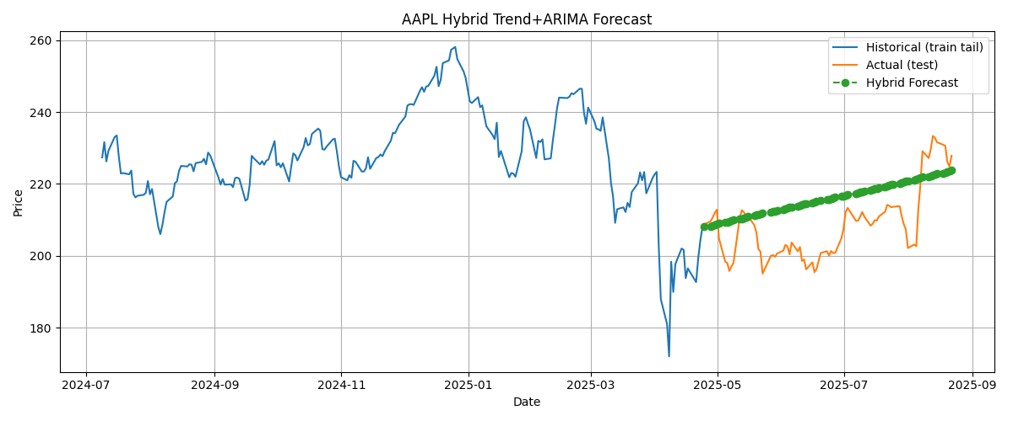

1.“AAPL_engineered_and_forecast” csv saved

2. “AAPL_future_forecast” csv saved  
  
**OUTPUT of** [**test_evaluate_forecast.py**](https://github.com/AnandSagar22/Stock-Forecast-Support-Resistance-Detector/blob/main/test_evaluate_forecast.py)**:**  
Loading CSV: AAPL_engineered_and_forecast.csv

Detected 2 events:

Date Actual Price Forecast Event Type

2025-05-01 20:00:00-04:00 204.848587 209.011224 support

2025-05-11 20:00:00-04:00 210.551041 210.161242 resistance  
  
